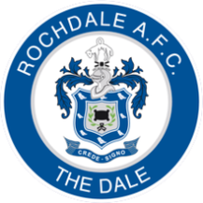

ROCHDALE COHESION CUP 2019

Soccer Factory, Royal Barn Road, Rochdale

Saturday 16 March 2019, 3.00PM – 6.00PM

Youth competition: 13 to 16 years old
Open age competition: 17+

It’s free to enter!

Prizes for the winners and runners up

Register by Thursday 14 March to take part.
Fill in this form and leave at reception or email syed.ali@rochdaleafc.co.uk
ROCHDALE COHESION CUP 2019 REGISTRATION

NAME*

ADDRESS*

DATE OF BIRTH*

GENDER*

PHONE NUMBER*

EMAIL ADDRESS*

ORGANISATION/PROJECT
(IF APPLICABLE)

MEDICAL CONDITIONS*
EMERGENCY CONTACT NAME*

EMEGENCY CONTACT NUMBER*

* Please be aware that the information collected is for registration purposes only and will not be shared without your consent.
Pictures or videos taken may be used for marketing purposes including social media, websites, leaflets, and posters. Please make it clear on your registration form or email if you do not wish to be included in pictures or videos.

