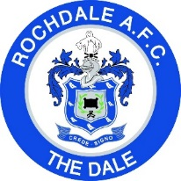
Rochdale v Gillingham FC
Saturday 15th September, Crown Oil Arena, 3pm Kick Off

M E N U

Starter
Carrot and Coriander Soup
Mains
Roast Chicken Breast in a Mushroom Cream Sauce Served with New Potatoes and Savoy Cabbage
Dessert
Strawberry Cheese Cake
Half-Time
Cake and Refreshment

